Hugging Face Model Execution in Google Colab

A Hugging Face pre-trained model was executed in Google Colab using the transformers library. The model was successfully run end-to-end, producing outputs for sentiment analysis and named entity recognition tasks.

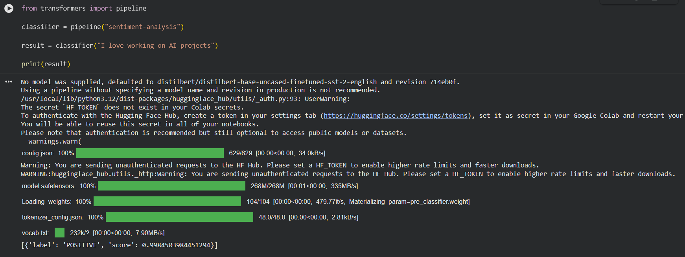

Figure: Execution of Hugging Face models showing sentiment analysis and entity recognition output
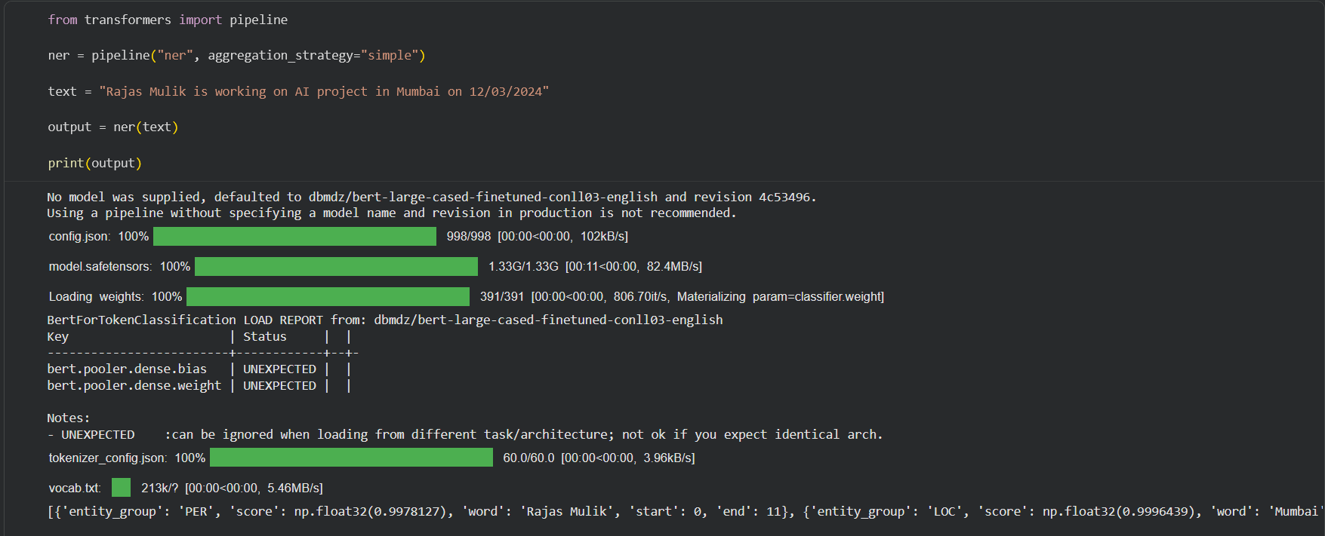

If the screenshots are not visible clearly, I have downloaded the colab file. If you want I can send it to you.

